Ghela, Vinesh

QA

Android tasks

Contents

Activities - Exploring Activity lifecycle methods 2

Intents - Simple Text app 3

Activity- Simple calculator 4

Intents - Simple calculator with intents 5

# Activities - Exploring Activity lifecycle methods

Your task is to create a project which utilises the activity lifecycle methods.

The methods you need to use are

* onCreate()
* onStart()
* onResume()
* onPause()
* onStop()
* onDestory()

*hint: use* ***Log.d*** *statements to print out when each method is executed.*

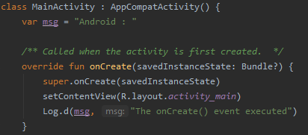

When you execute your application, in the run window should see the following log statements

**Open the application**

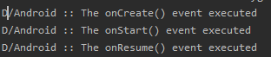

**Exit the application**







# Intents - Simple Text app

Your task is to create a simple text app

* Should take in one or more input field(s)
* When the submit button is pressed it should take you to a new activity and display the parsed information.

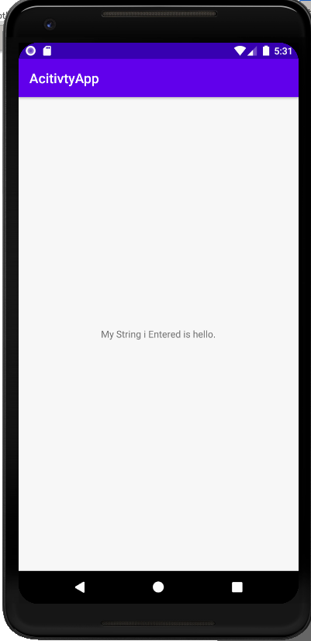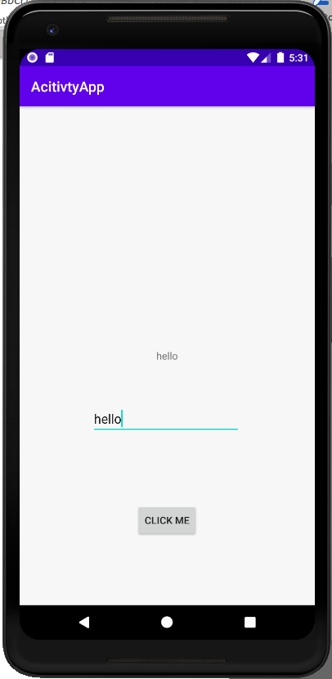

# Activity- Simple calculator

You task is to create a single page calculator

* Both numbers should be a float
* Create 4 buttons which when clicked will carry out the corresponding calculation
  + Add
  + Subtract
  + Multiply
  + Divide

No1:

* The total will be displayed at the bottom

No2:

# Intents - Simple calculator with intents

You task is to create a calculator that each operator creates a new activity.

* Both numbers should be a float
* 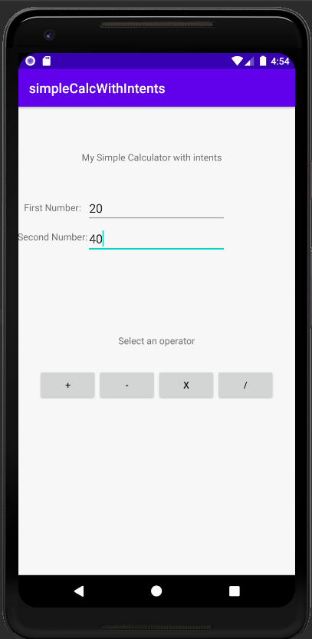Create 4 buttons which when clicked will carry out the corresponding calculation on a new activity.
  + Add
  + Subtract
  + Multiply
  + Divide

The total will be displayed at the new activity.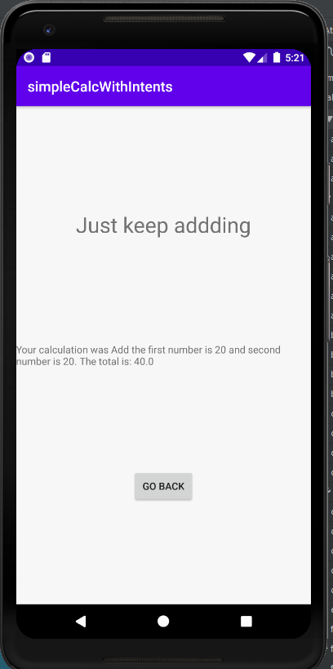 For each activity feel free to customise the page also adding any images strings or buttons.

**Bonus task :** try to pass the calculation to one activity and perform the relevant calculation as well as any changes to make the activity specific to that operator that is selected.